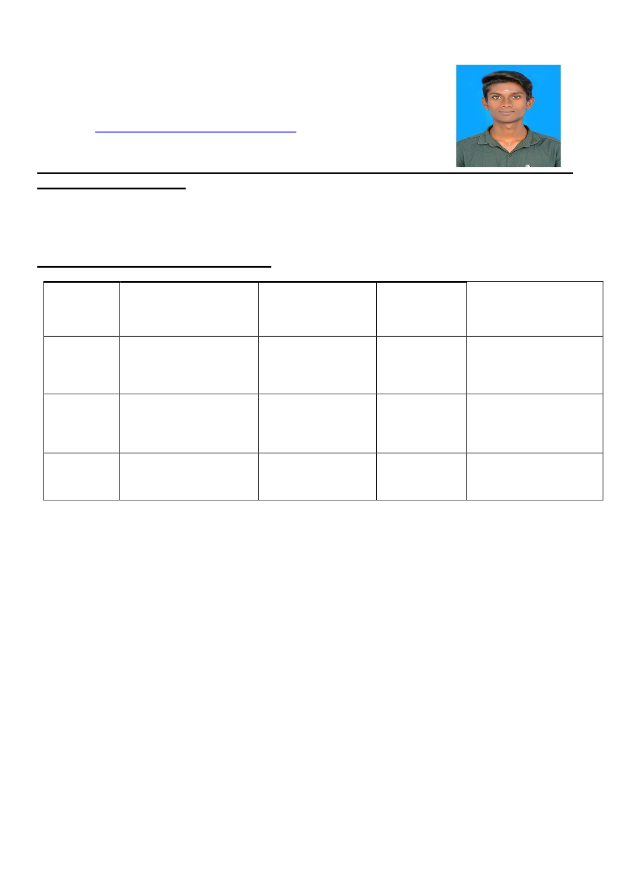
RESUME
R. LOKESH
210/1, Angalamman nagar maniyanoor,
Salem-636010
Mail ID : lokeshravikumar9042@gmail.com
Mobile No: 7010559420
CAREER OBJECTIVE
Which updates my knowledge. Improve my skills and provides a room to give out my To work in a challenging environment best to the organization
ACADEMIC ACCOMPLISHMENT:
COURSE | INSTITUTION | BOARD OF | YEAR OF | PERCENTAGE
 |  | UNIVERSITY | PASSING

BBA | Mahendra | Periyar university. | 2020 | 65%
HSC | Arts&Science | Salem. | 2017 | 70%
 | college.kallippati
 |  | Stateboard
 | Gugai Hr.sec.school.
salam
SSLC | GugaiHr.sec.school. | Stateboard | 2015 | 68.%
salem
•Currently Working in Cholamandalam as a Collecction Officer from Dec 2022 to Current.& Working in 1
To 7 + Bucket.
Sana Associates (Feb 2021 to Dec 2022)
Job Profile; Field Officer –Secured & Unsecured Collections –Recovery Write-off
•Working in Write-Off cases of EL, of SBI Bank, INB, IB,KVB banks portfolio behalf of Reliance ARC in Agency Sana Associates.
•Routine of Working Structure is Daily field visit for agency allocated cases and giving feedback regards visited cases every day evening.
•This is both secured and Unsecured case but my major part of work is EL loans
Sudharsan Agency
Job Profile; Field Officer –TW Collections – BKT 2 & 3

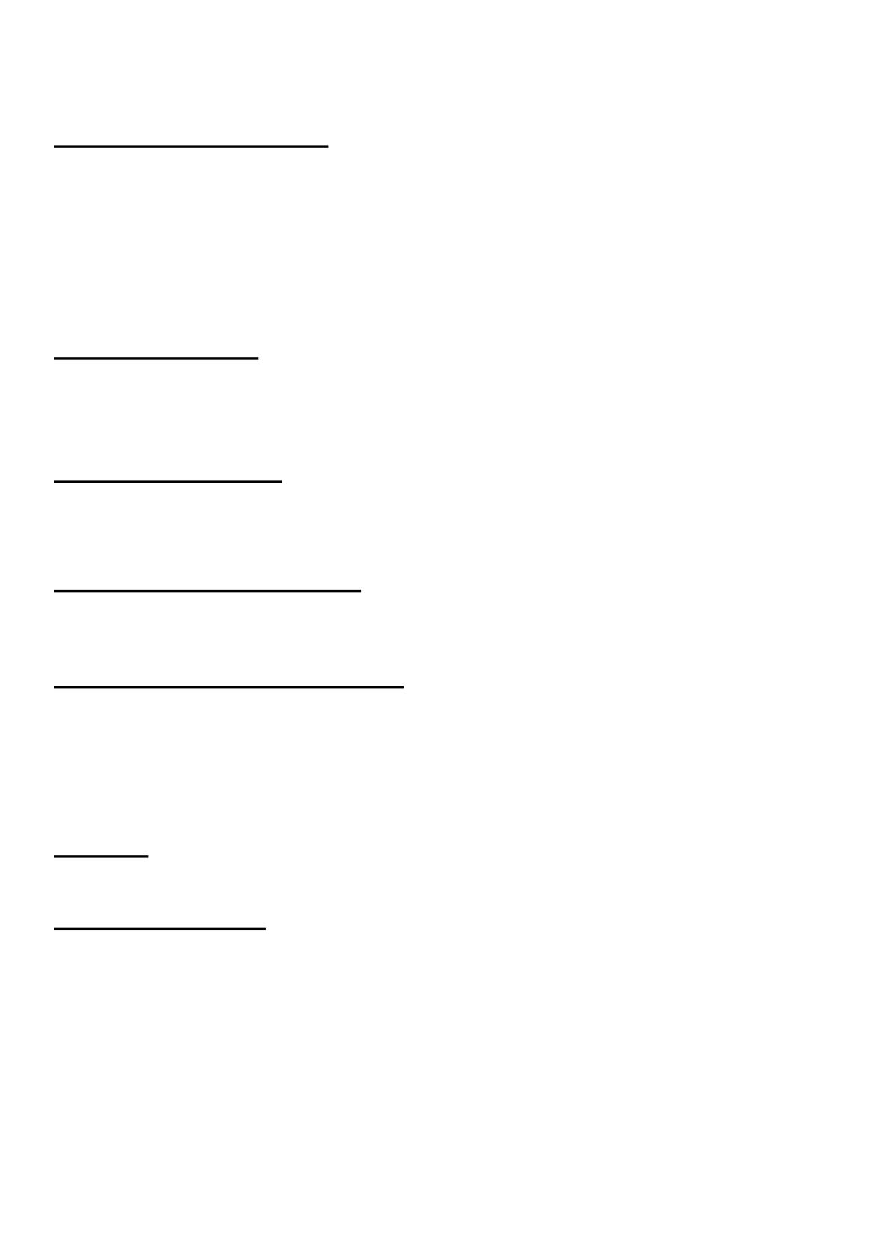
•Worked in TW BKT Collections for Bajaj Auto Finance from 2019 to 2020 March.
•My base of 200 accounts with 20 Lakhs
COMPUTER PROFICIENCY
Packages : Ms office.
Type writing
Tally ERP9
Hardware & software
AREA OF INTEREST
Marketing (Retail segment)
Banking financial service and insurance
PROJECT PRESENTED
Done summer internship at MRF TYERS.
A study on market potential for MRF TYERS.
SPECIAL MARKETING EVENT
Participating ADZ-JOB ACTIVITIES IN MARKETING PRODUCTS.
EXTRA CURRICULAR ACTIVITIES
MEMBER OF NATIONAL SERVICE SCHEME (NSS)
Fencing.
Ball badminton.
HOBBIES
Cricket and social media
PERSONAL PROFILE
Father’s Name : P. Ravikumar
Date of Birth : 12:02:2000
Gender : Male
Language known : English, Tamil (Read, write, speak)


DECLARATION:
I hereby declare that the above information is true to the best of my knowledge and belief
Thanking you
DATE : Yours faithfully,
PLACE : R.LOKESH

